# User Manual for Eviden - Asset Manager

This user manual provides a step-by-step guide to perform common actions in the Eviden - Asset Manager. The following sections detail how to register, log in, sign out, and manage assets and customers.

## ****Authorisation****

### **Register**

1. Click on the **Register** link in the Eviden - Asset Manager interface. 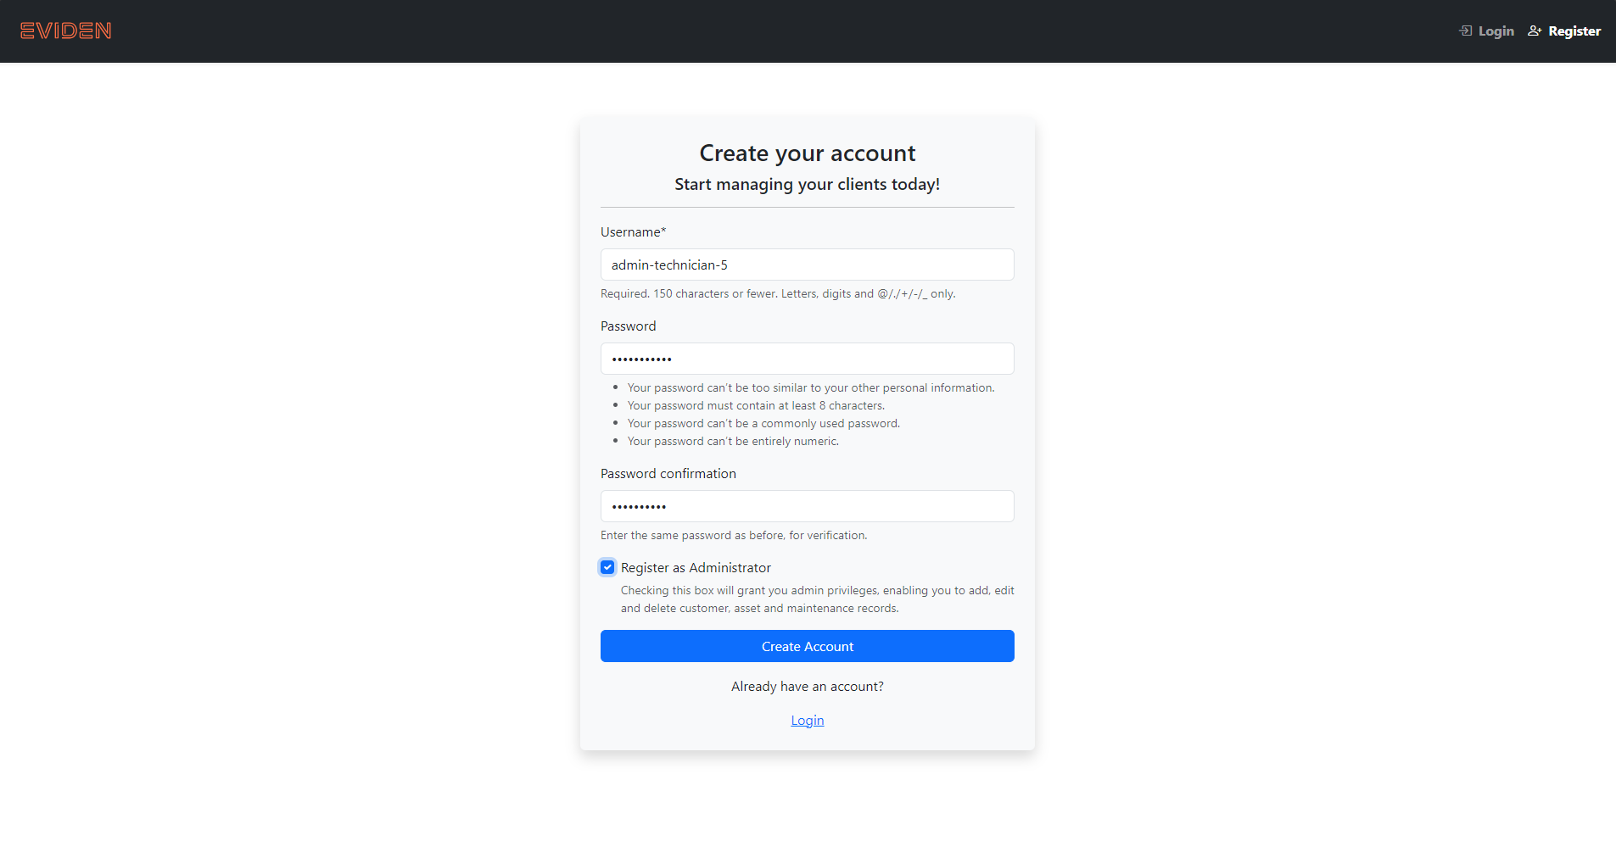
2. Fill in the registration form:
   * **Username**: Enter your desired username.
   * **Password**: Enter and confirm your password in the respective fields.
   * (Optional) Check the **Register as Administrator** box if you want to register as an administrator.
3. Click the **Create Account** button to complete the registration process.
4. After registering, you will be automatically logged in and greeted with a welcome message. 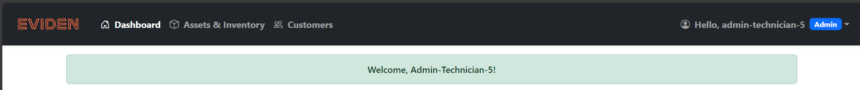

### **Log In**

1. On the login page, enter your registered username in the **Username** field. 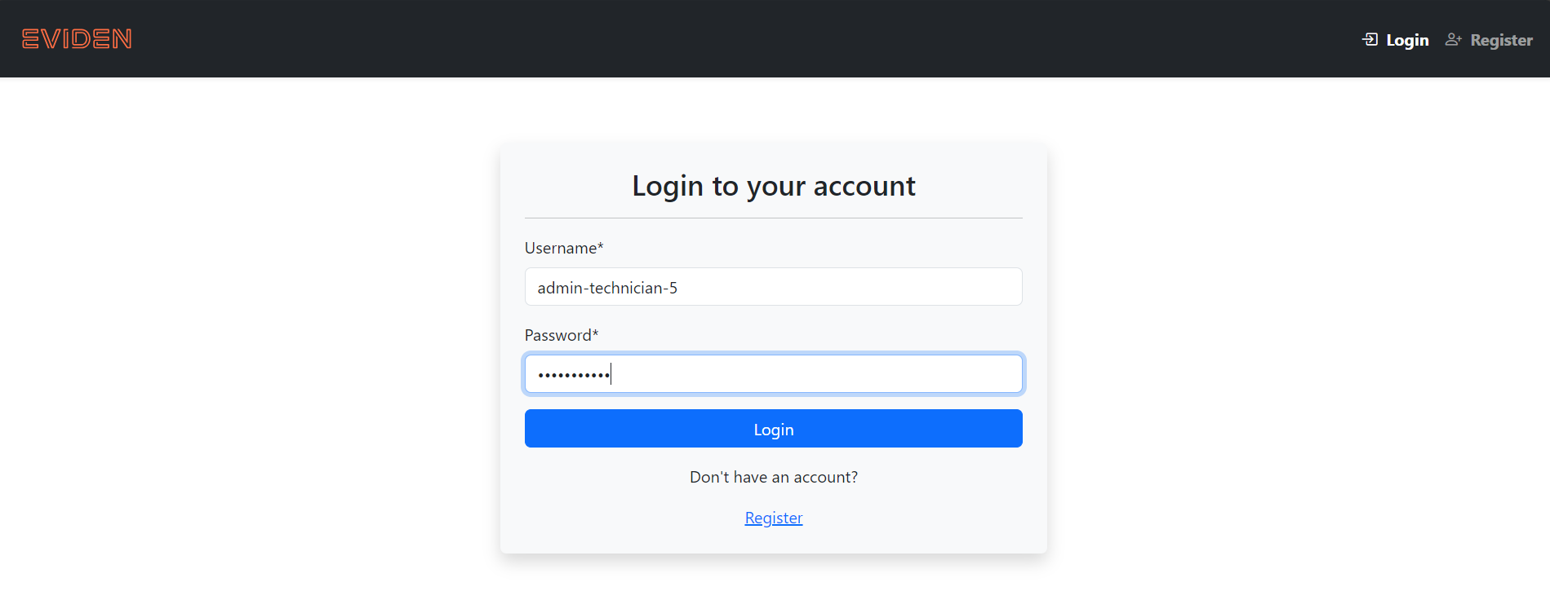
2. Enter your password in the **Password** field.
3. Click the **Login** button to access your account.
4. After logging in, you be greeted and greeted with a welcome back message.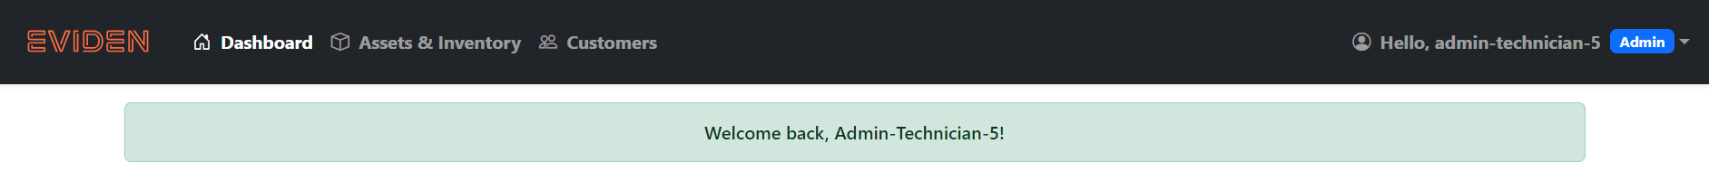

### **Sign Out**

1. Click on the **Hello, [username] Admin** button (or equivalent) in the top navigation bar.
2. From the dropdown menu, select the **Sign Out** option. 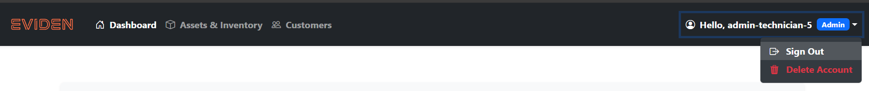
3. You will be logged out and redirected to the login page.

### **Delete Account**

1. Click on the **Hello, [username] Admin** button (or equivalent) in the top navigation bar.
2. In the dropdown menu, locate and click the **Delete My Account** option. 
3. A confirmation prompt will appear. Click the **Yes, Delete My Account** button to permanently delete your account. 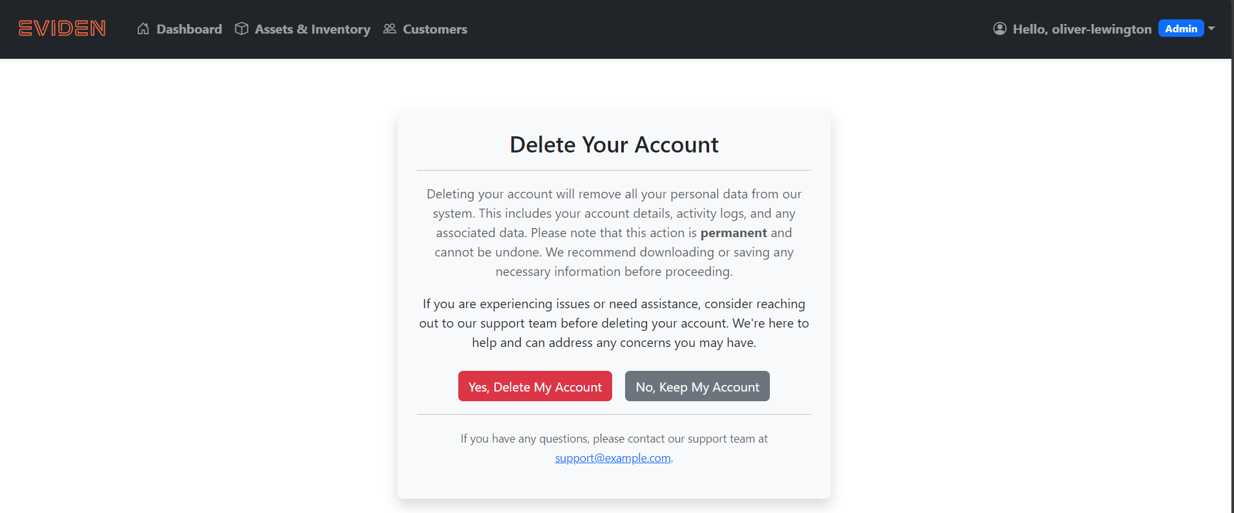

**Tip:** Ensure all information is entered accurately to avoid errors during registration or login. If issues persist, contact your administrator or support team.

## ****Asset Features****

This guide explains how to perform essential tasks related to managing Assets in the application.

### **Steps for Adding an Asset**

1. Navigate to the **Assets & Inventory** section in the application. 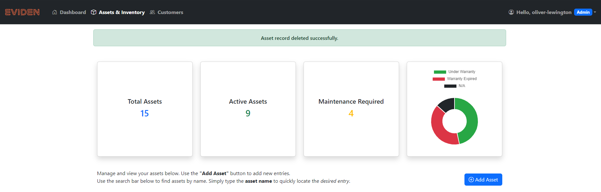
2. Click **Add Asset**. 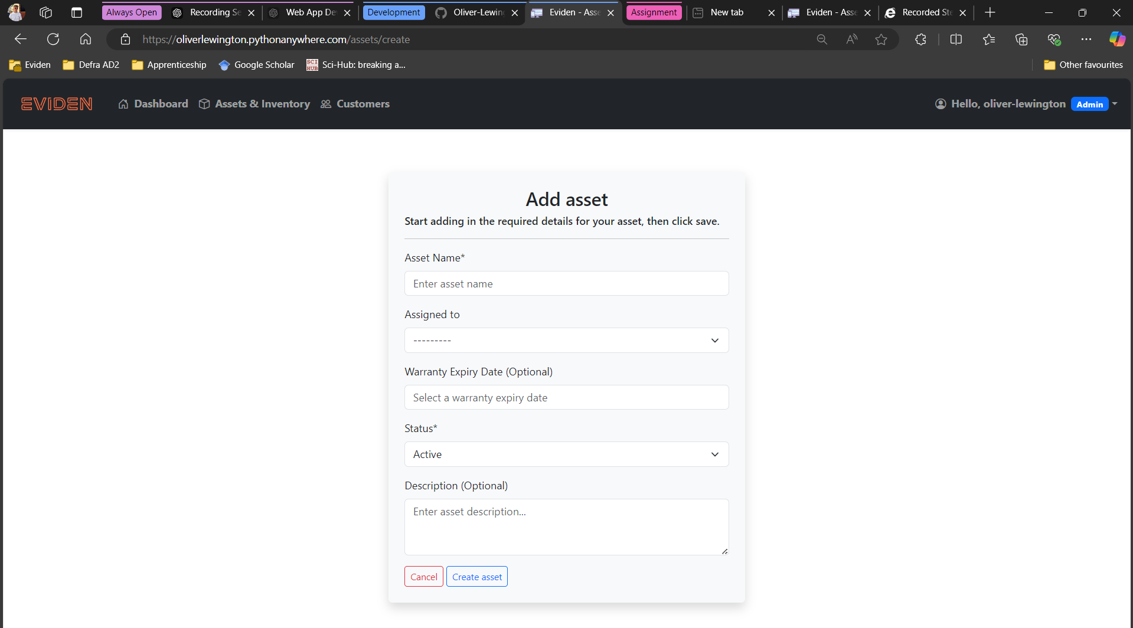
3. Fill in the required fields:
   * **Asset Name**: Enter the asset's name.
   * **Assigned To**: Select a user.
   * (Optional) **Warranty Expiry Date**: Choose a date.
   * (Optional) **Description**: Provide additional details.
   * **Status**: Set the current asset status.
4. Click **Create Asset** to save. 

### **Steps for Adding Maintenance**

1. Navigate to the specific asset and click **View**.
2. Click **Add Maintenance**. 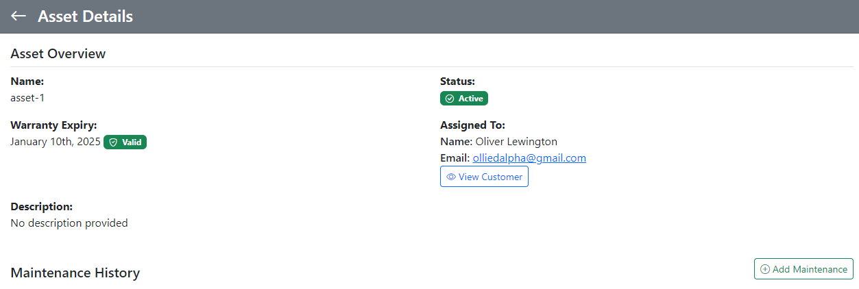
3. Fill in the required fields:
   * **Performed By**: Select the technician.
   * (Optional) **Description**: Provide maintenance details.
4. Click **Create Maintenance** to save. 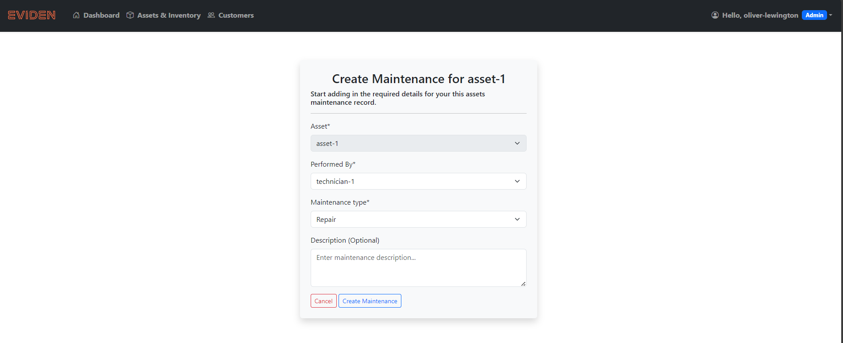

### **Steps for Editing or Deleting Maintenance**

1. Navigate to the specific asset and click **View**.
2. Find the maintenance entry you want to edit or delete. 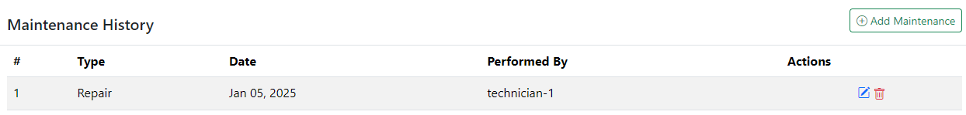
3. To **edit**, click the pencil icon:
   * Update the necessary fields as described in the **Adding Maintenance** section.

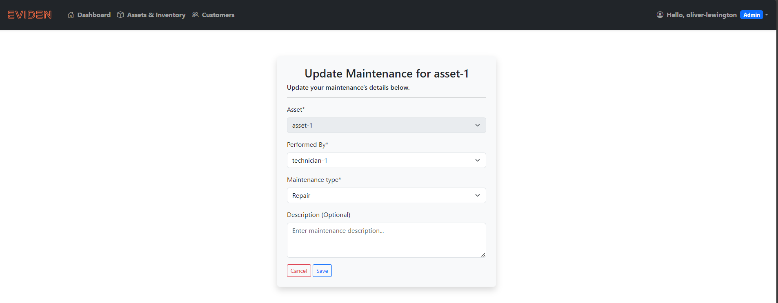

1. To **delete**, click the trash bin icon and confirm the deletion.

### **Steps for Searching for an Asset**

1. Navigate to the **Asset** section in the application.
2. Locate the **Search Asserts** bar at the top of the page. 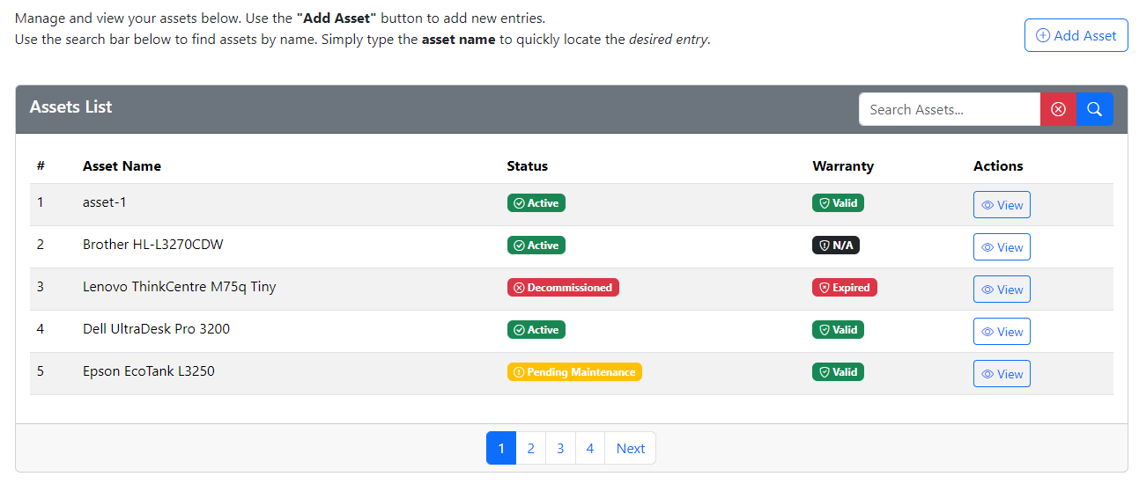
3. Click into the search bar and type an asset name.



1. Press **Enter** or click the **Search** button (indicated by a magnifying glass icon).
2. Review the filtered results to find the desired asset record. 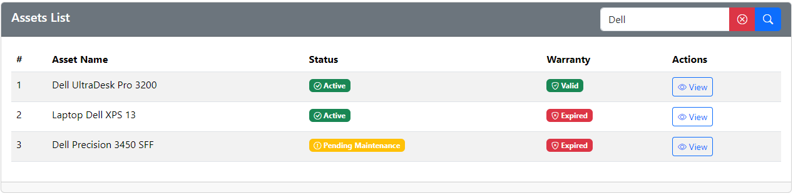

**Additional Details:**

* The search bar automatically narrows down results based on your input.

### **Steps for Editing an Asset**

1. Navigate to the asset list and locate the asset. 
2. Click **Edit Asset**. 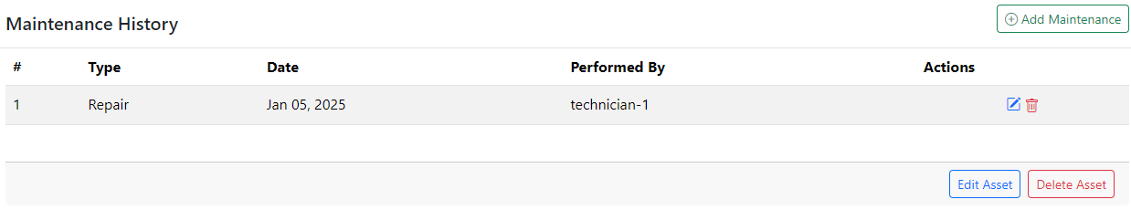
3. Update the necessary fields (e.g., name, assigned user, warranty date, etc.). 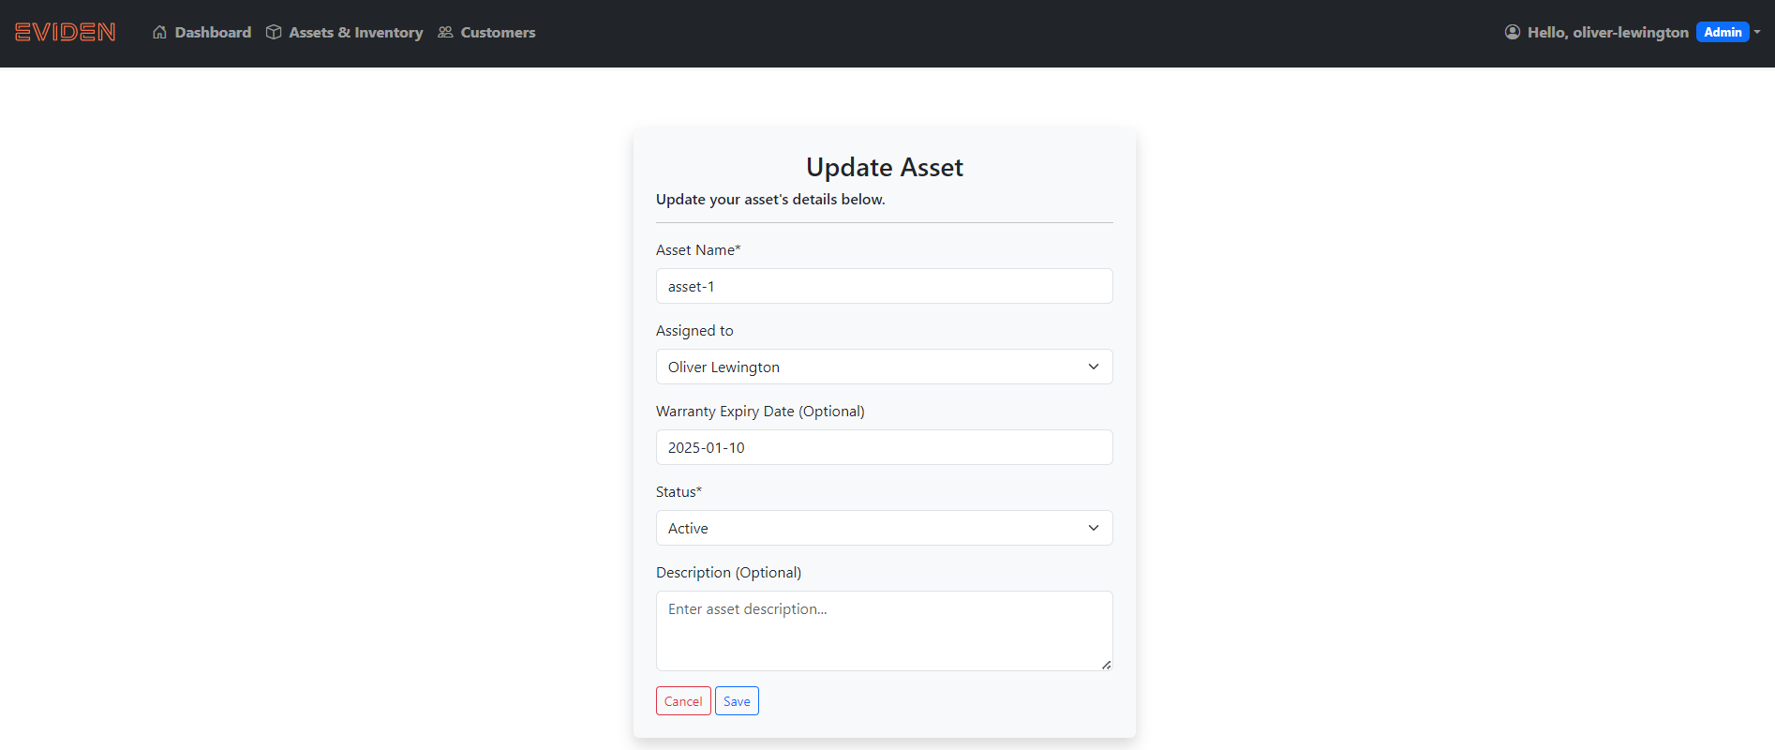
4. Click **Save Changes** to update the asset.

### **Steps for Deleting an Asset**

1. Navigate to the asset list and locate the asset. 
2. Click **Delete Asset**. 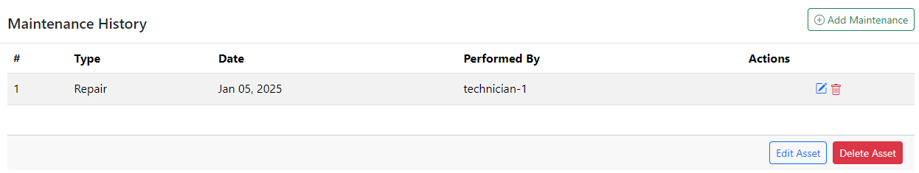
3. Confirm the deletion when prompted. 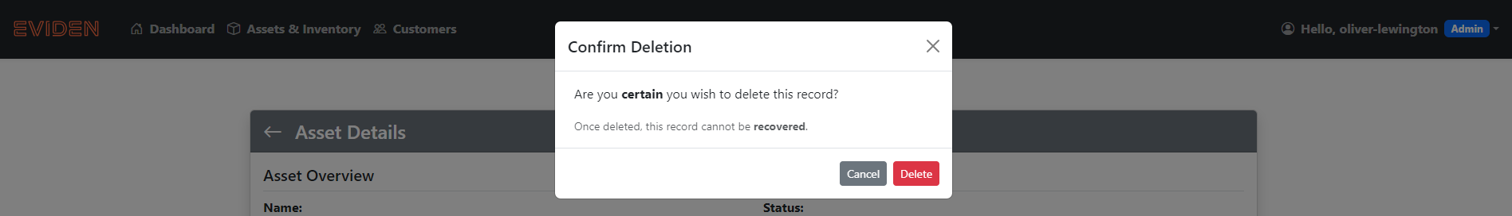

## ****Customer Features****

This guide explains how to perform essential tasks related to managing customers in the application.

### **Steps for Adding a Customer**

1. Navigate to the **Customers** section in the application. 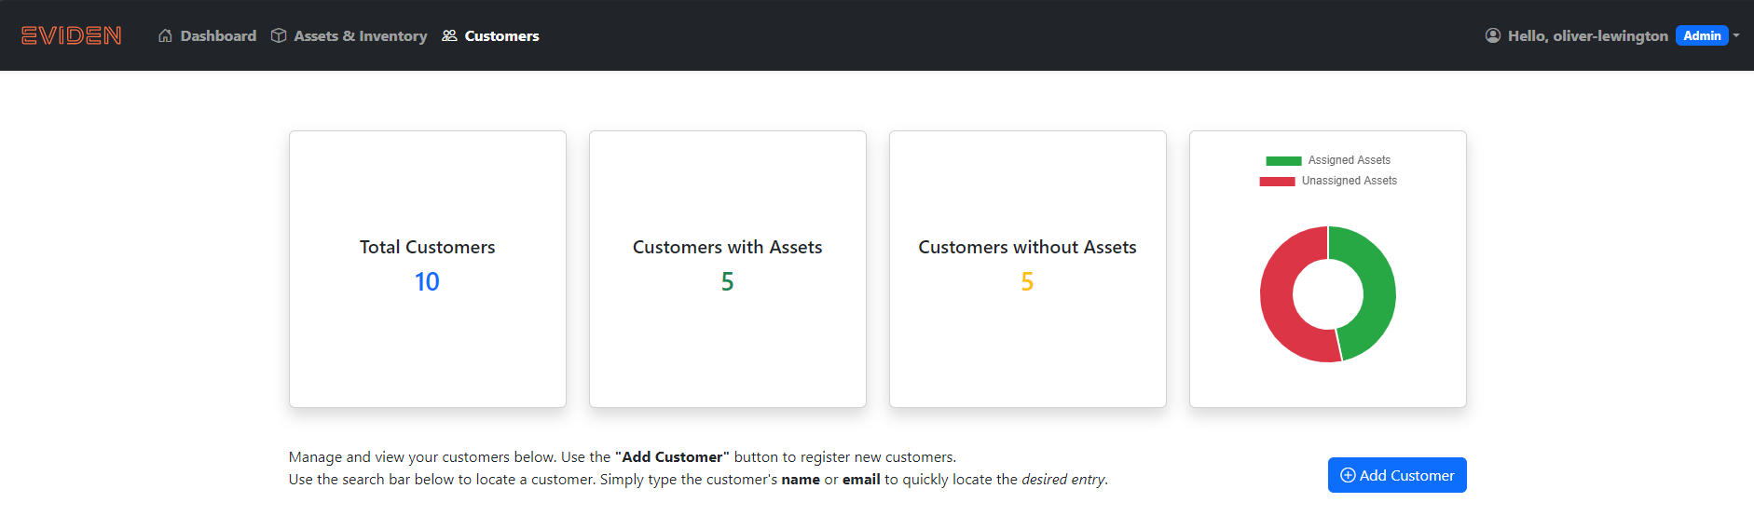
2. Click on the **Add Customer** button.
3. Fill in the required fields:
   * **Customer Name**: Enter the customer's name.
   * **Contact Details**: Provide an email address or phone number.
   * **(Optional) Address**: Enter the customer's physical or mailing address.
   * **Status**: Indicate the customer's current status (e.g., Active, Inactive).

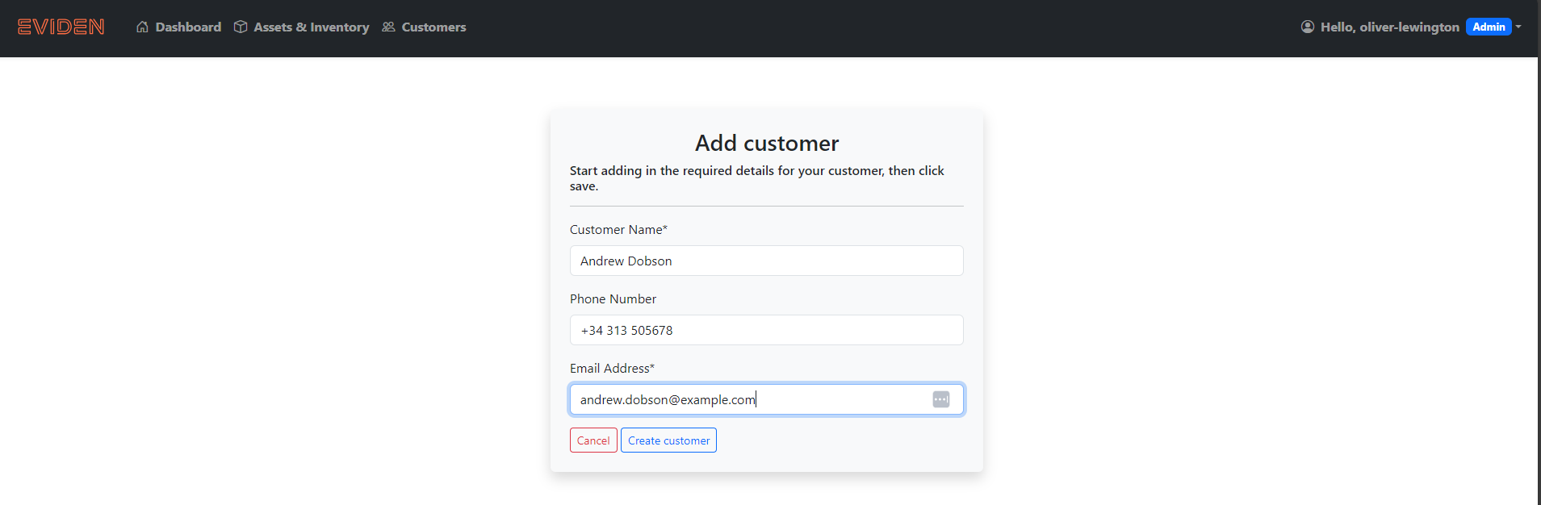

1. Click on the **Create Customer** button to save the customer record.

### **Steps for Searching for a Customer**

1. Navigate to the **Customers** section in the application.
2. Locate the **Search Customers** bar at the top of the page. 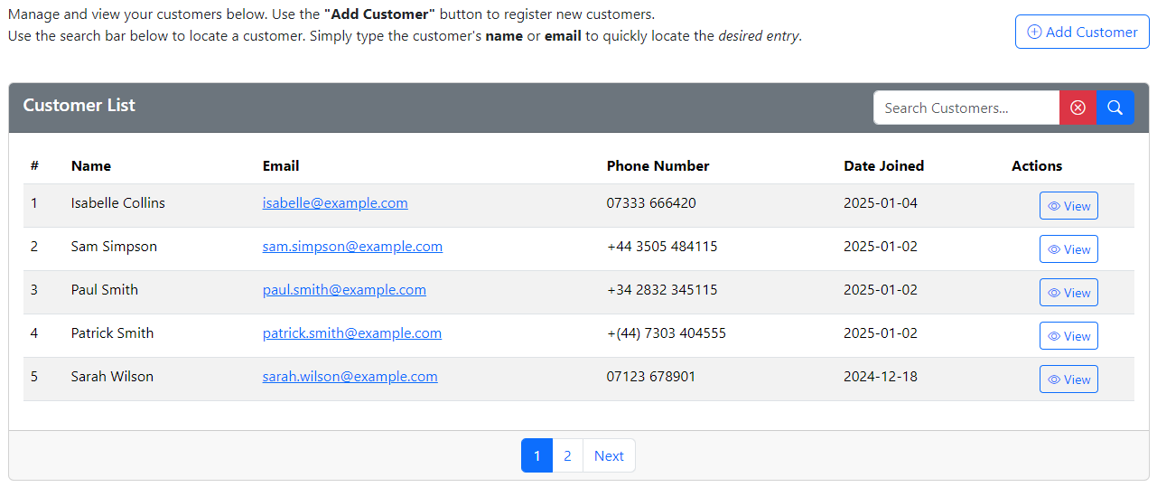
3. Click into the search bar and type the name, email, or other identifying detail of the customer. 
4. Press **Enter** or click the **Search** button (indicated by a magnifying glass icon).
5. Review the filtered results to find the desired customer record. 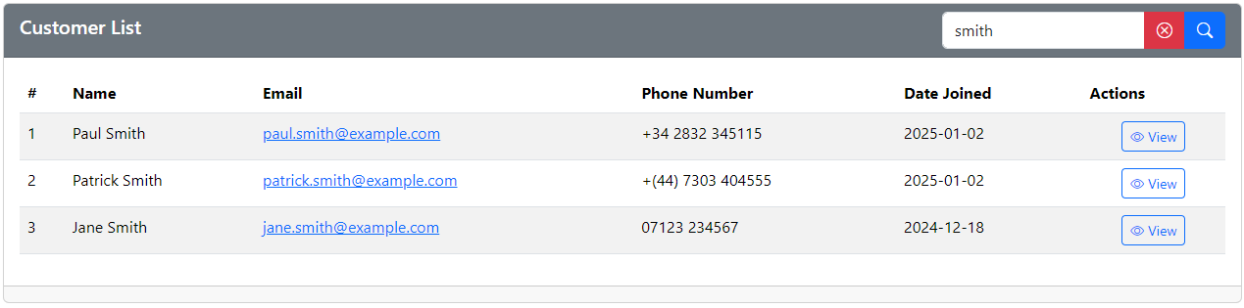

**Additional Details:**

* The search bar automatically narrows down results based on your input.

### **Steps for Editing a Customer**

1. Navigate to the **Customers** section and locate the customer you want to update. 
2. Click on the **Edit Customer** button. 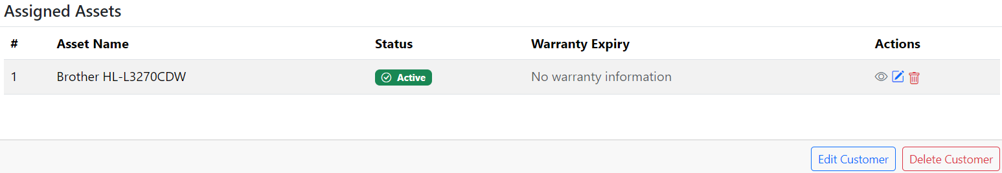
3. Update the necessary fields (e.g., name, contact details, status). 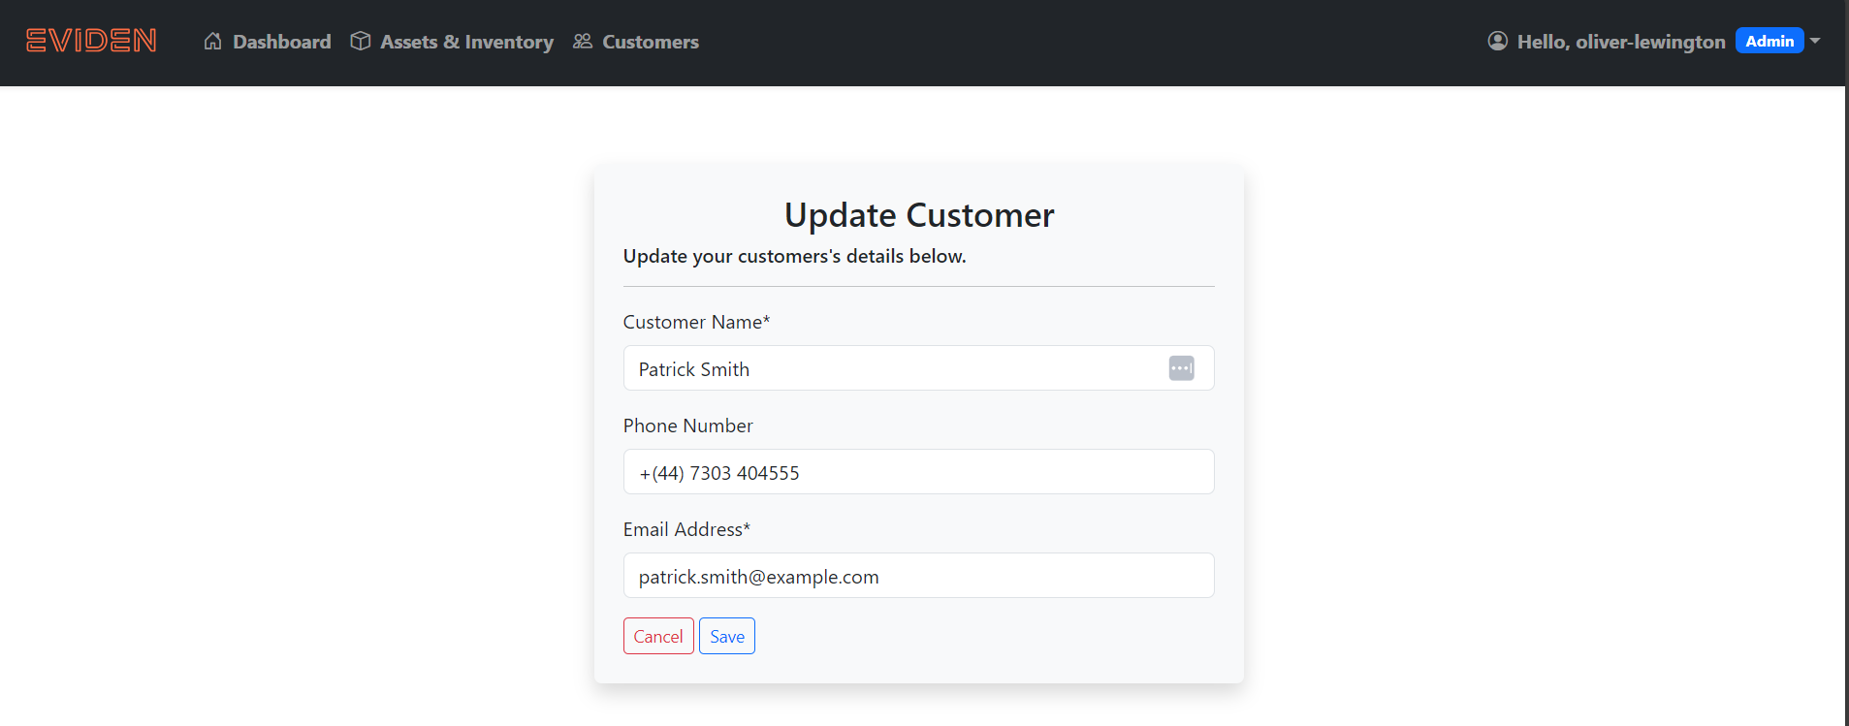
4. Click on the **Save Changes** button to apply the updates.

### **Steps for Deleting a Customer**

1. Navigate to the **Customers** section and locate the customer you want to remove. 
2. Click on the **Delete Customer** button. 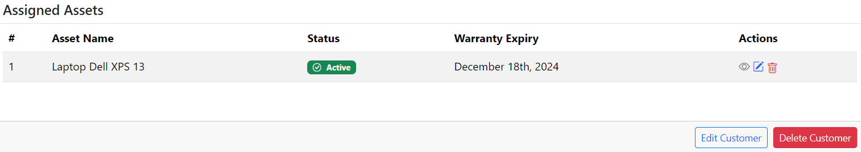
3. Confirm the deletion when prompted to permanently remove the customer record. 